Doubts:

1. How to make an account in GIT hub to create a repository?
2. While doing RDS instance

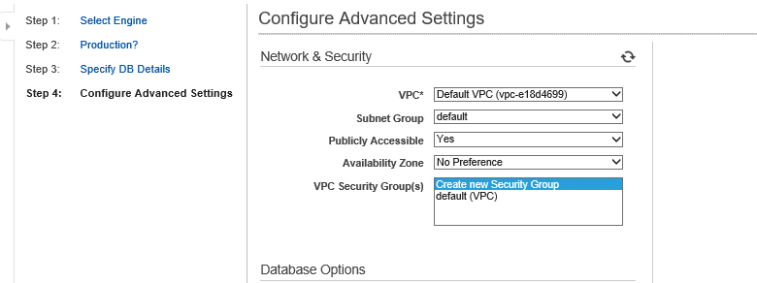

Here,

Publicly Accessible is yes

That means EC2 instances outside VPC, it will be having access to that Database.

So, Here, we r making access publicly open which is huge security risk.

After creating RDS,

And how to connect it from EC2 instance?